# Oracle APEX

Oracle Application Express is a rapid web application development tool for the Oracle database. Using only a web browser and limited programming experience, you can develop professional applications that are both fast and secure. Thanks to built-in features such as user interface themes, navigational controls, form handlers, and flexible reports, Oracle Application Express accelerates the application development process.

From the end user's perspective, the deployed applications require only a browser and access to an Oracle database running Application Express.

**PROJECTS**

Please watch the following video about a **Simple Movie Application development** using ORACLE APEX and start using the platform. Please provide screenshots of your development activities on ORACLE APEX platform.

[Low Code App Dev with Oracle APEX: Building a Simple Movie App - YouTube](https://www.youtube.com/watch?v=VlYa5xkF_kE)

Ans: -

Movie database and Reporting App

**Report on Oracle APEX Application Development: Movie Database and Reporting App**

**Student Reporter:**

Name : Wasik Gaus

ID: K240381

**Date:** 04/06/2025

**Objective:** This report details the development process of a "Movie Database and Reporting App" undertaken using the Oracle Application Express (APEX) platform. The primary goal was to demonstrate the capability of APEX in rapidly creating a functional web application, including data loading, user interface generation, and basic reporting features, as per the assigned task.

**Development Activities Overview:**

The development process, as evidenced by the provided screenshots, followed a systematic approach:

1. **Platform Initialization and Project Setup:**
   * The process commenced within the Oracle APEX environment, starting from the main dashboard.
   * The "App Builder" module was utilized to initiate the creation of a new application. At this stage, the workspace indicated no pre-existing applications or tables.
2. **Data Acquisition and Preparation:**
   * External data was sourced from Kaggle, specifically the "TMDB 5000 Movie Dataset."
   * An initial review of the dataset structure, particularly the tmdb_5000_credits.csv file, was conducted on the Kaggle platform to understand its columns (e.g., movie_id, title, cast, crew).
3. **Data Loading into APEX:**
   * The acquired movie dataset was successfully loaded into the Oracle APEX environment.
   * The "Load Data" utility in APEX confirmed the processing of 4,803 rows into a table named "TMDB5000" under the schema "WKSP_SYAD2001".
4. **Application Creation and Configuration:**
   * The "Create Application" wizard in APEX was employed to define the structure and features of the application, named "Tmdb5000b".
   * Several standard pages were configured, including a Home page, a Dashboard, a Faceted Search page ("Tmdb5000b Search"), an Interactive Report with Form ("Tmdb5000b Report"), and a Calendar page.
   * Essential application features such as Access Control, Activity Reporting, and Theme Style Selection were incorporated during this stage.
   * The APEX platform then automatically generated the application components based on these specifications.
5. **Application Deployment and Initial Testing:**
   * Upon successful generation, the application was installed and made accessible.
   * The application included a standard login page for user authentication.
   * Post-login, the main navigation provided access to the configured pages: Dashboard, Search, Report, and Calendar.
6. **Observed Application Functionality:**
   * **Dashboard:** The Dashboard page presented several charts visualizing key metrics from the loaded movie data, such as "Budget," "Original Language," "Popularity," and "Release Date."
   * **Interactive Report:** The "Tmdb5000b Report" page displayed the movie data in a comprehensive tabular format, allowing for interactive exploration of details like budget, genres, overview, and popularity.
   * **Administration:** An administration section was also generated, providing tools for application configuration, user interface management, activity monitoring, and access control.

**Conclusion:** The sequence of activities demonstrates a successful end-to-end development cycle of a simple web application using Oracle APEX. The platform facilitated the rapid ingestion of external data, the automated generation of user interface components including forms and reports, and the creation of a functional application with standard features. This project effectively showcases the low-code capabilities of Oracle APEX for building data-driven applications.

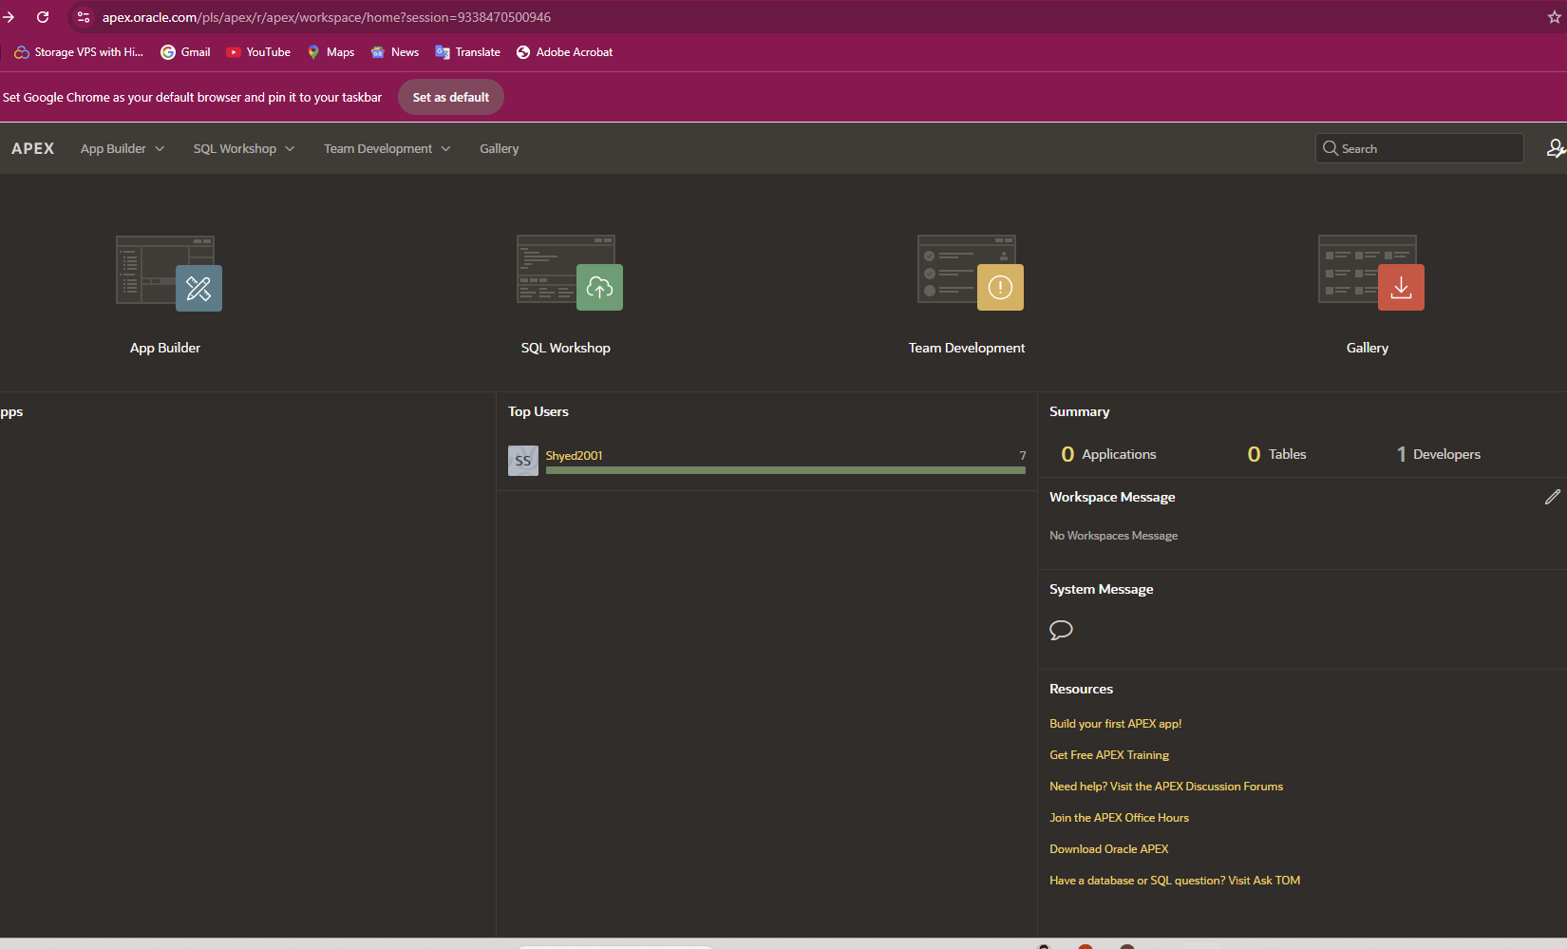

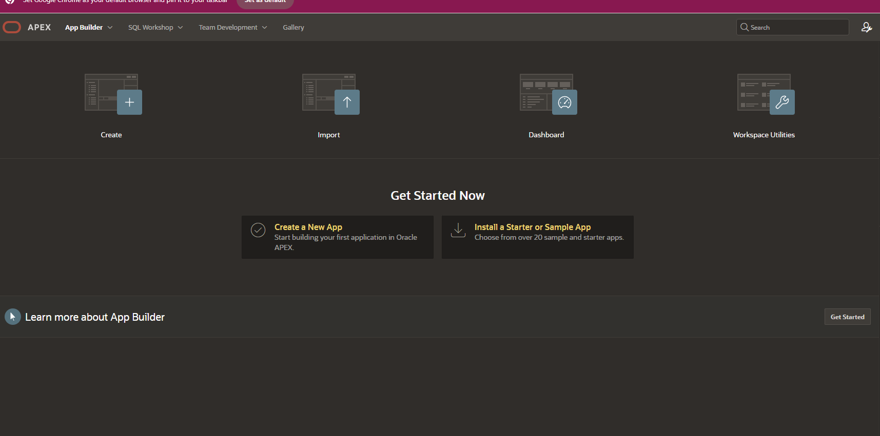

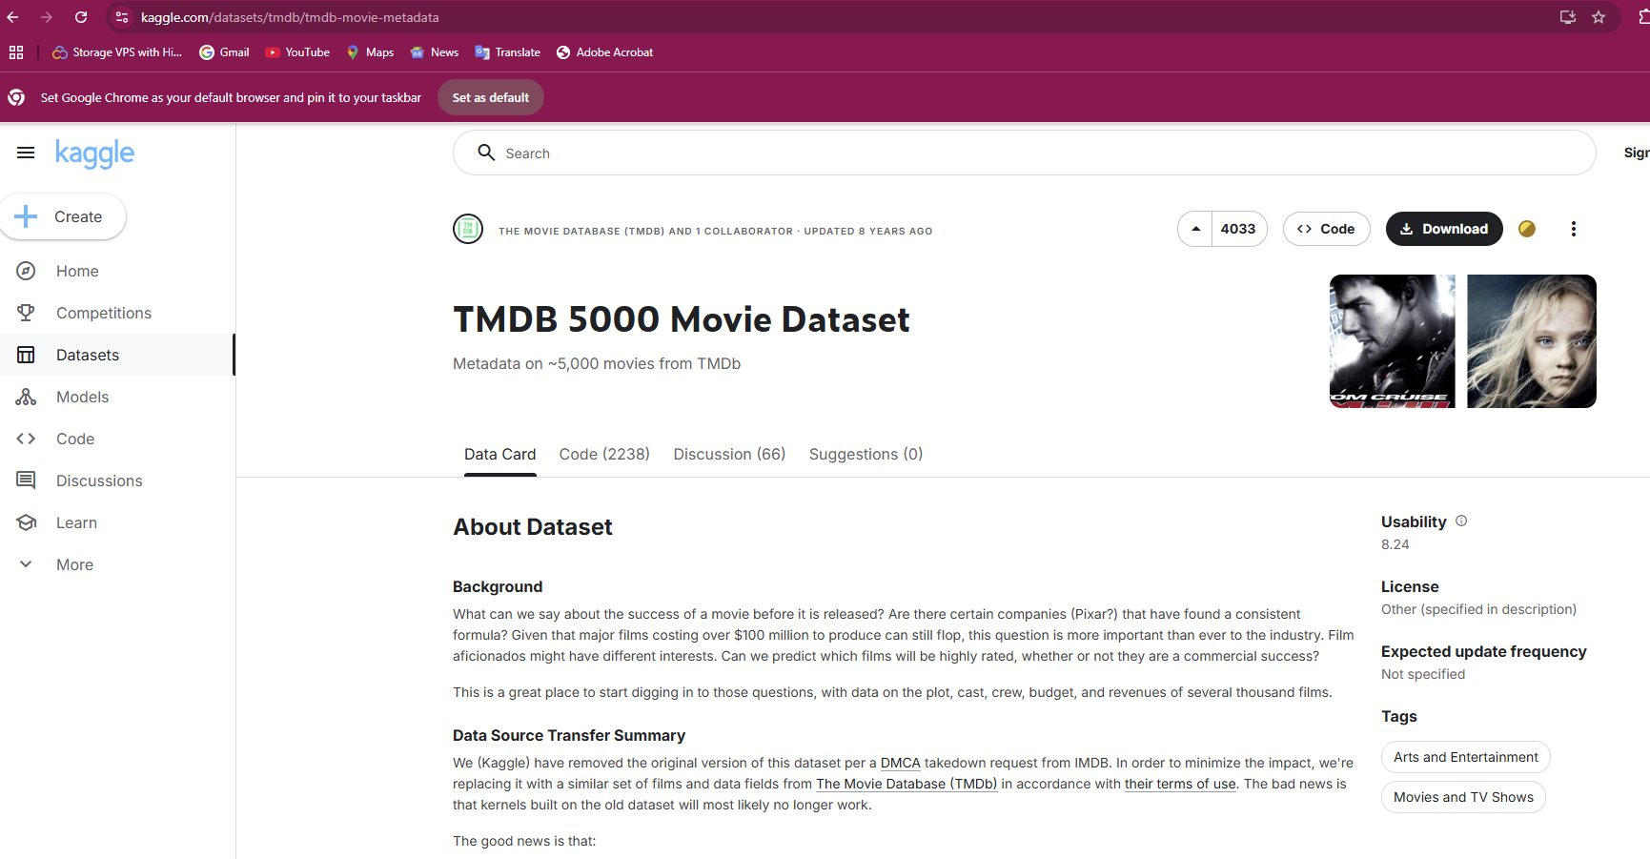

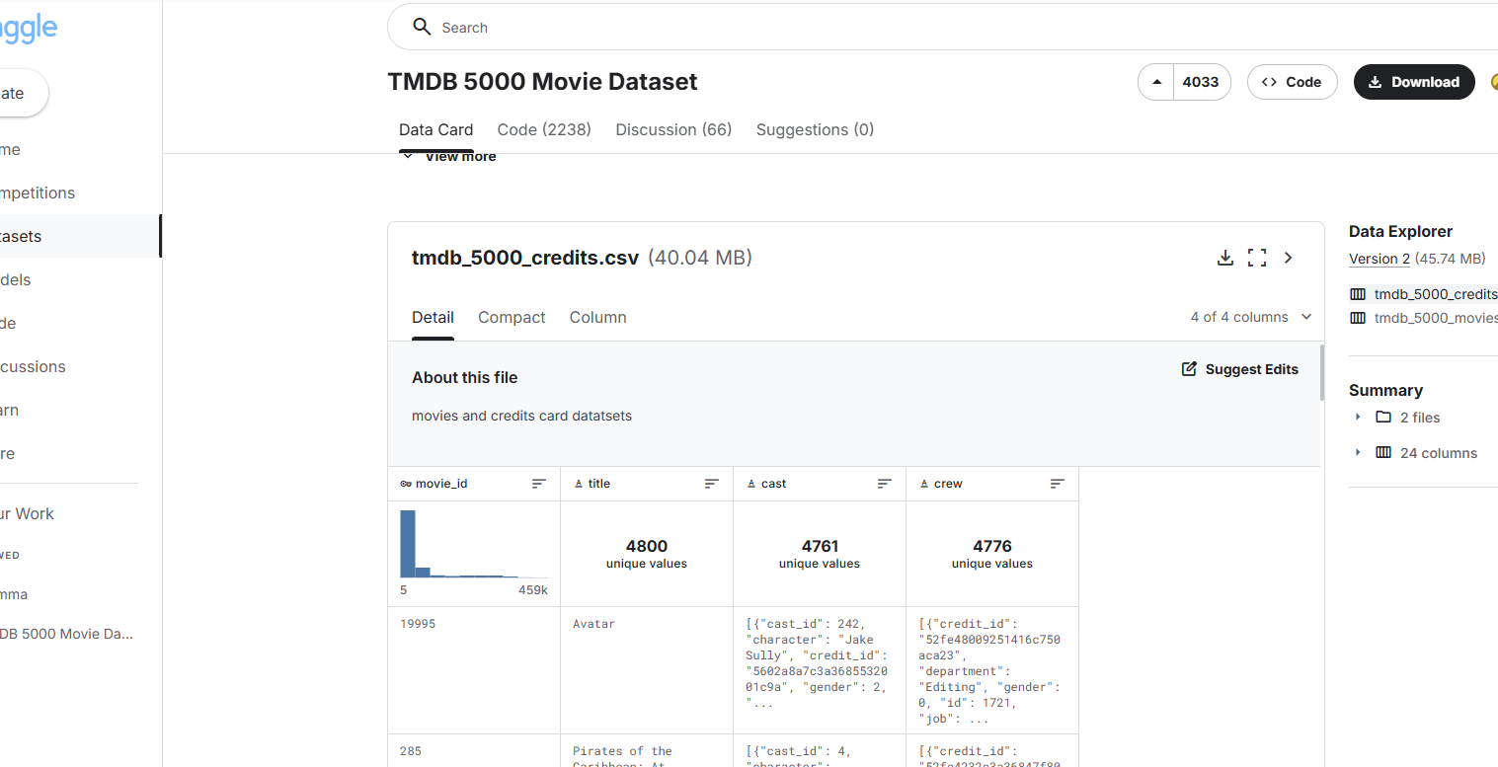

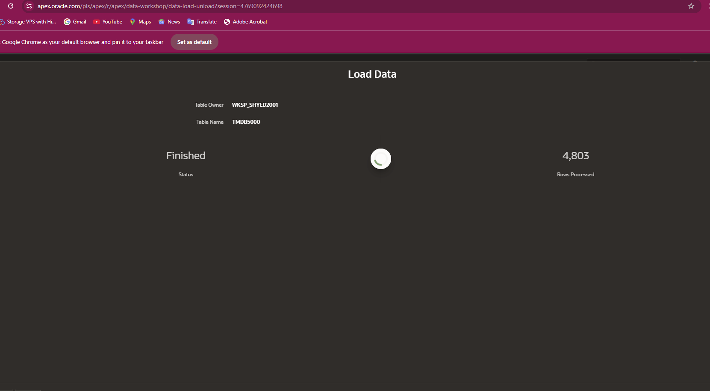

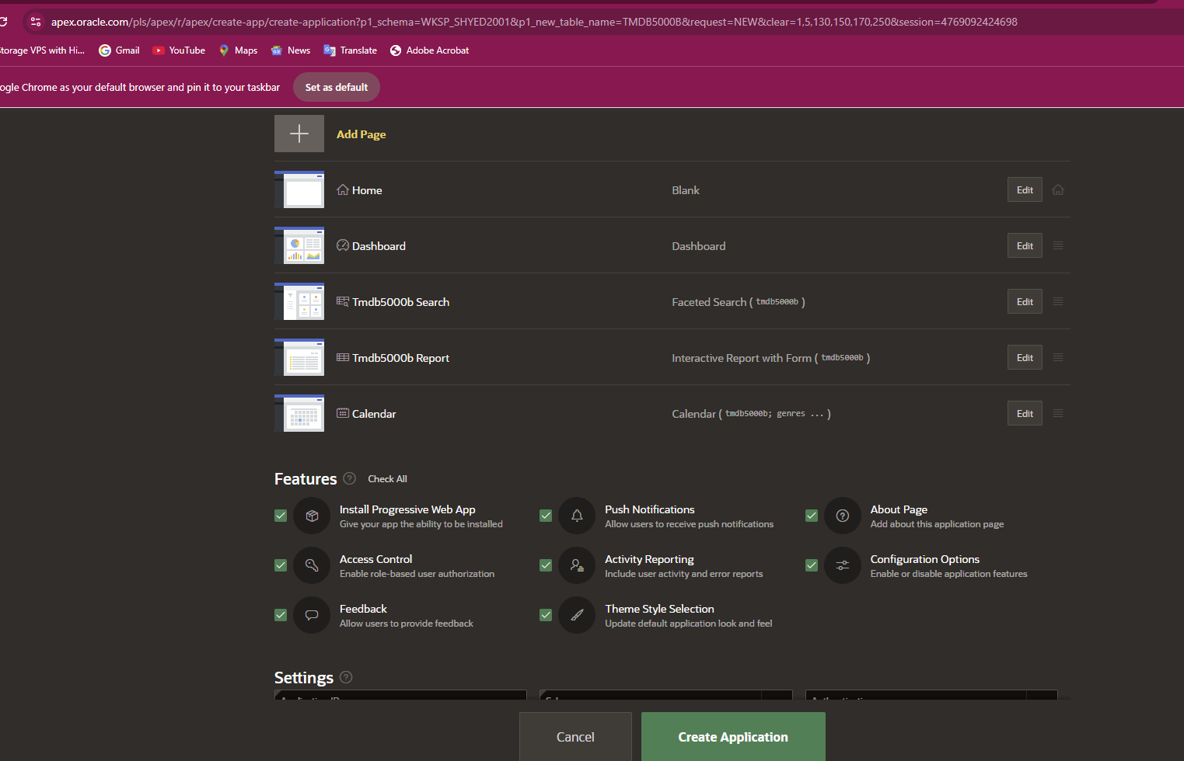

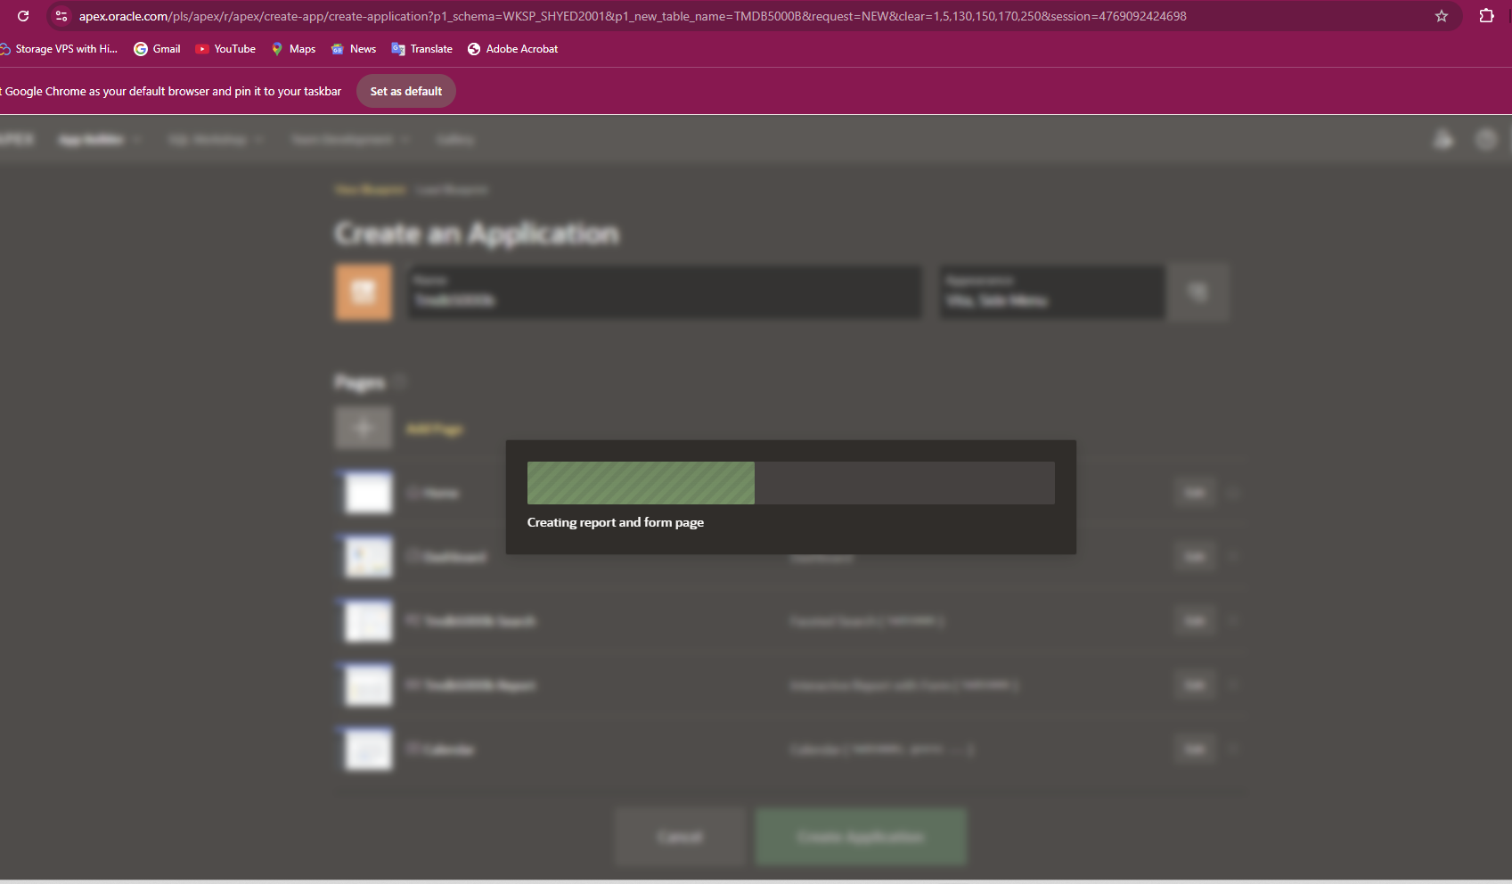

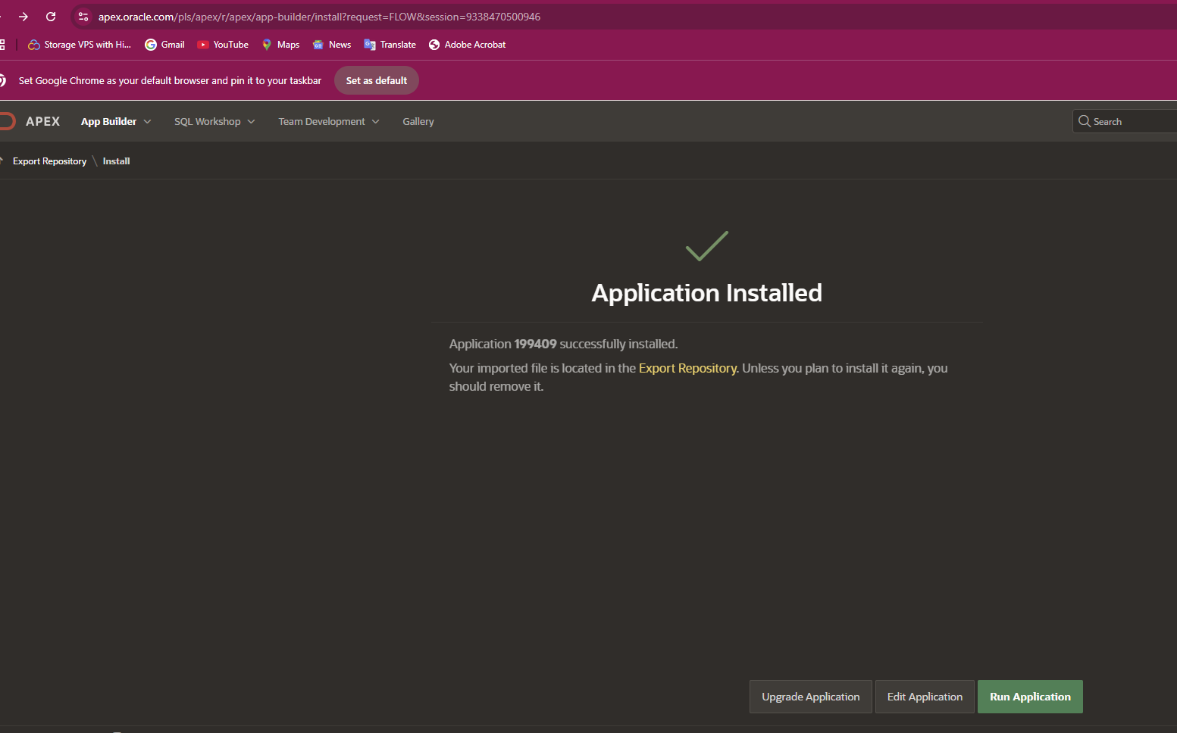

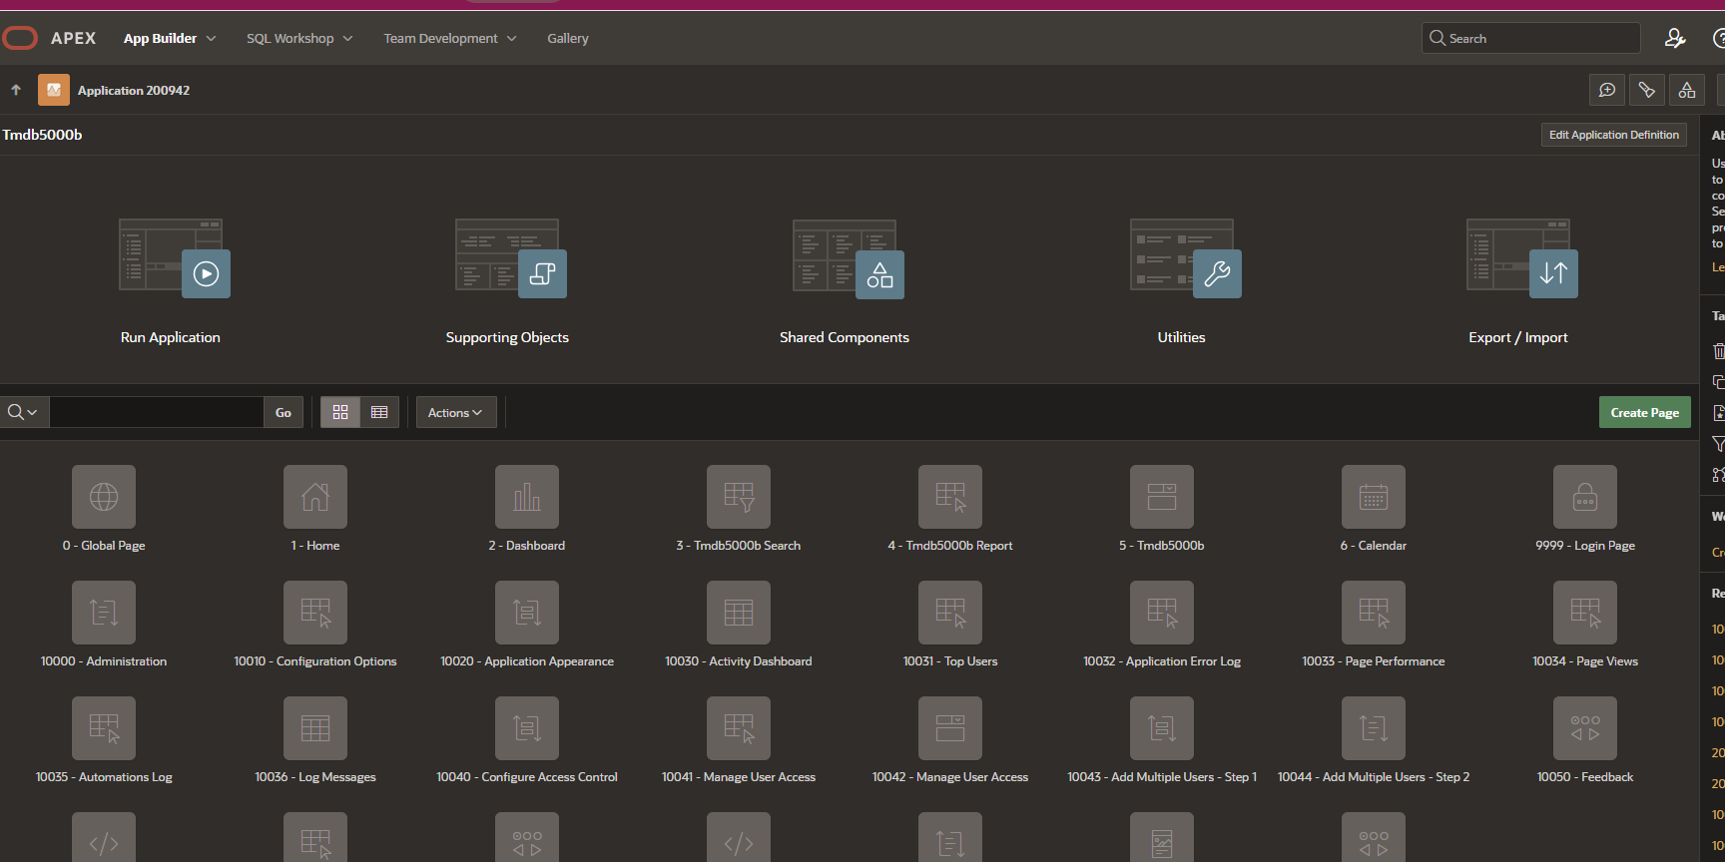

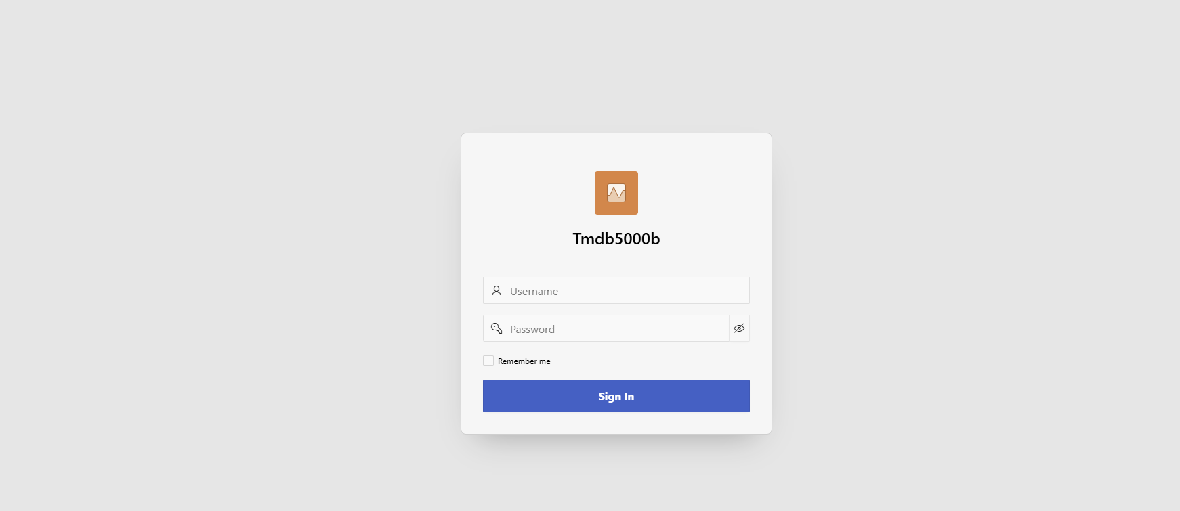

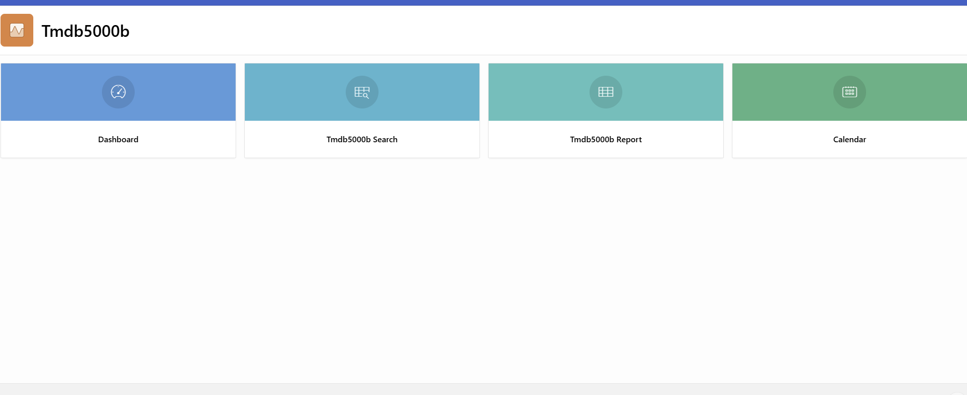

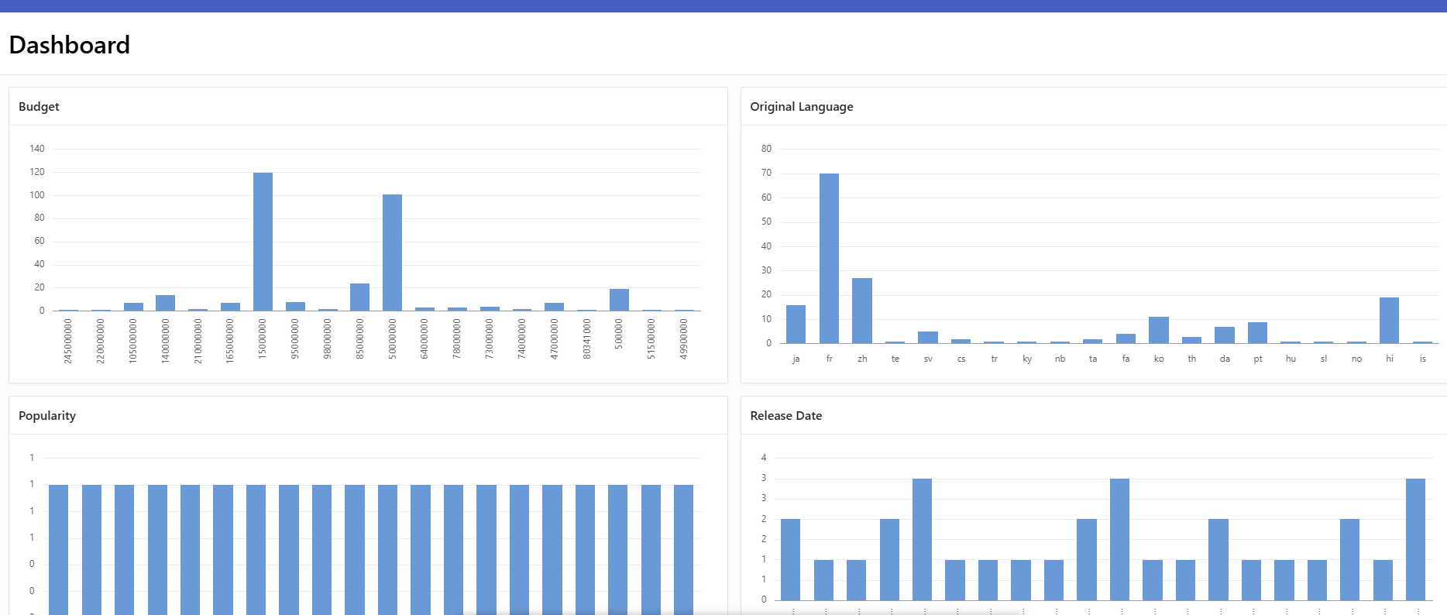

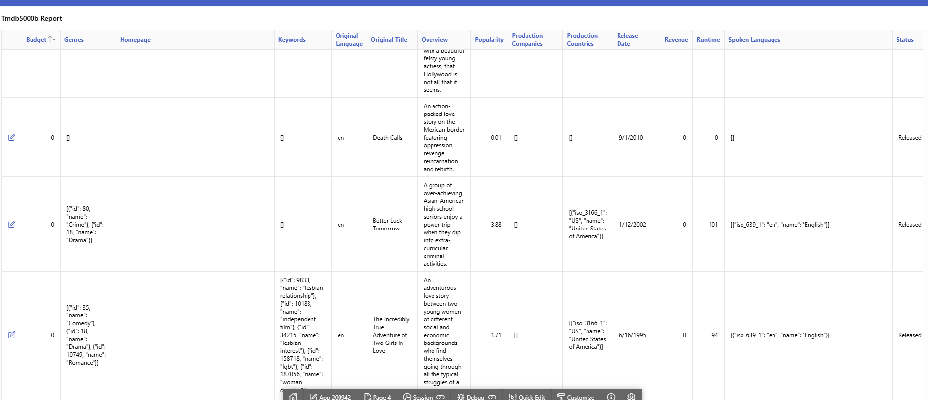

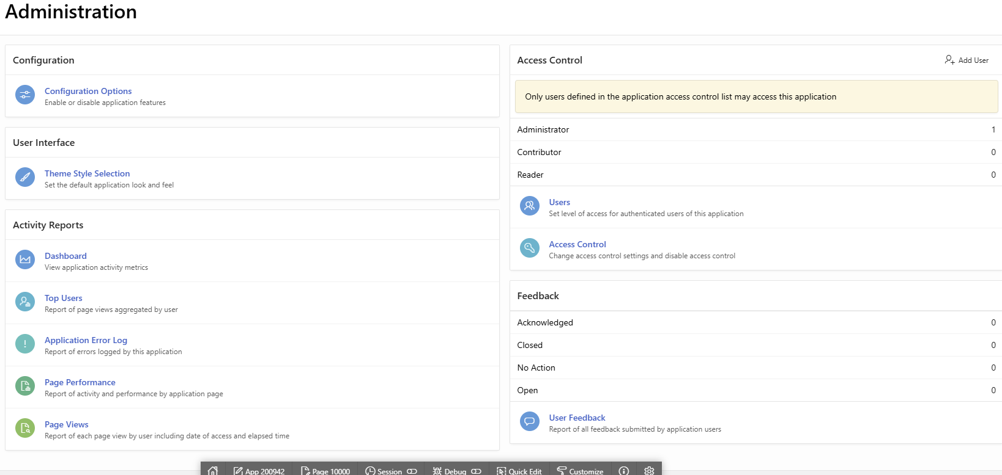

**Developer successfully went through the process of:**

* Identifying and obtaining an external dataset (TMDB 5000 Movies from Kaggle).
* Loading this data into their Oracle APEX environment.
* Using the APEX App Builder to create a new web application with several pages (Home, Dashboard, Search, Report, Calendar) and features.
* Generating the application, which included a login page.
* Running the application to view the dashboard with data visualizations and an interactive report of the movie data.
* Accessing the administration section of the application for further configuration and monitoring.